BINARY TO DECIMAL

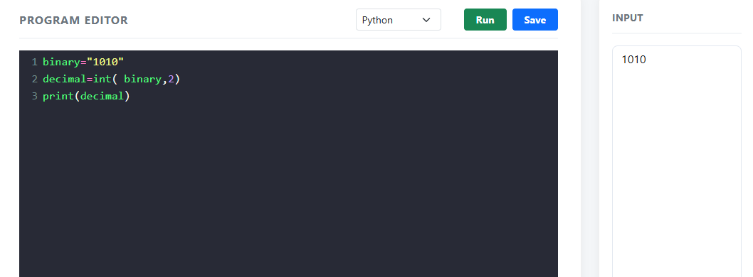
DECIMAL TO BINARY
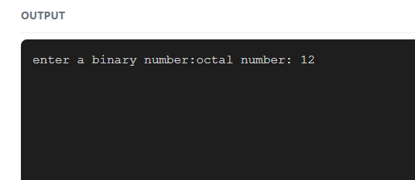
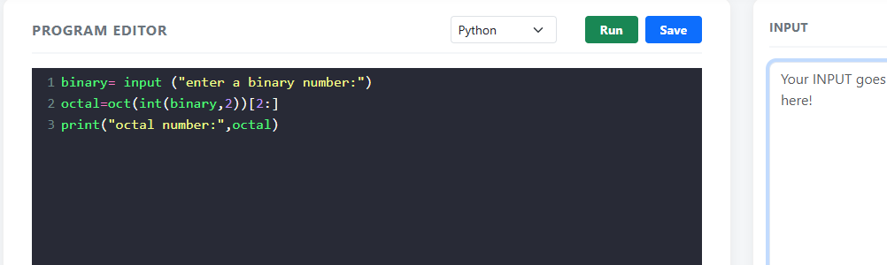
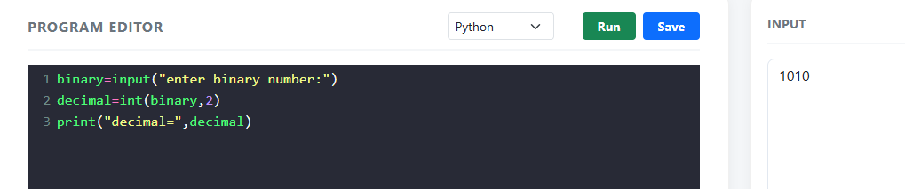
OCTAL TO BINARY
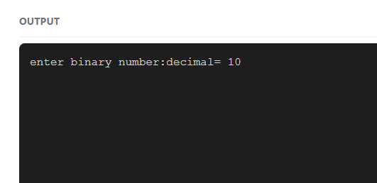
DECIMAL TO OCTAL
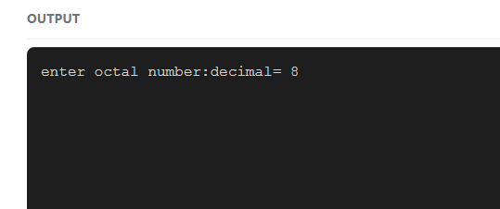
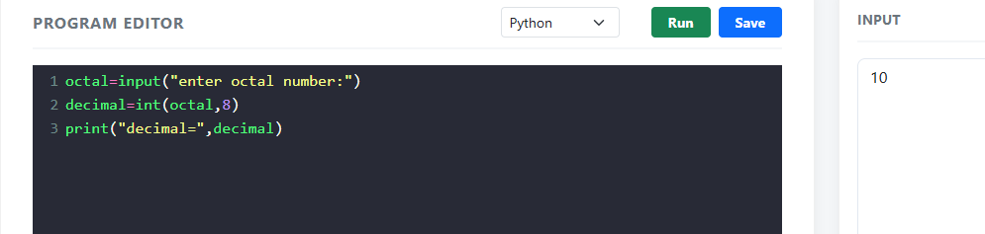
DECIMAL TO HEXADECIMAL
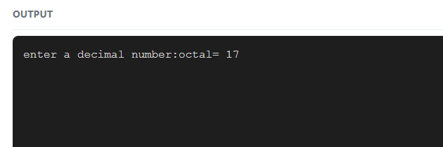
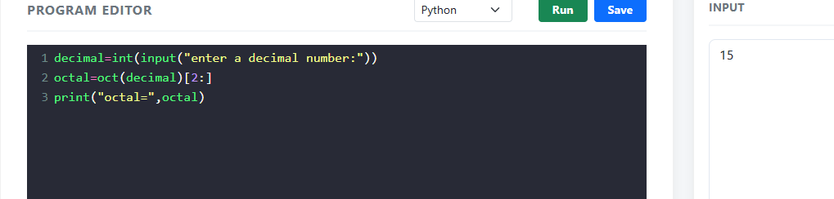

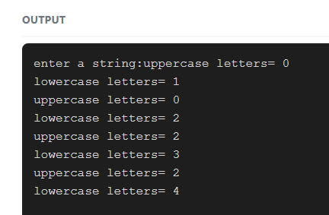
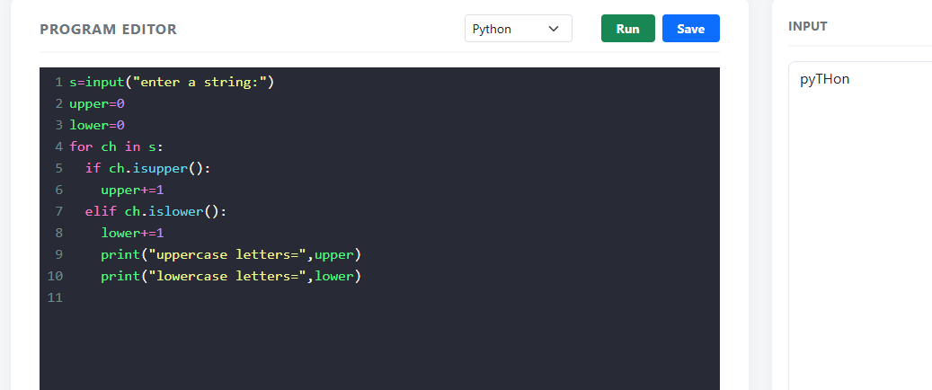
COUNT UPPERCASE AND LOWERCASE
COUNT ALPHABETS,DIGITSAND SPECIAL CHARACTERS
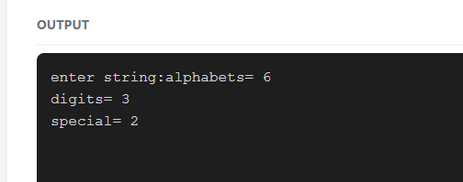
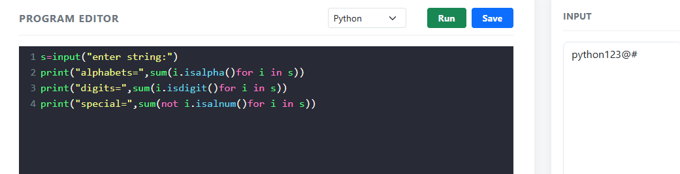
CHECK WETHER A STRING IS PALINDROME
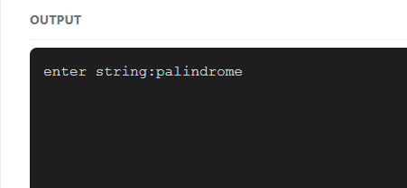
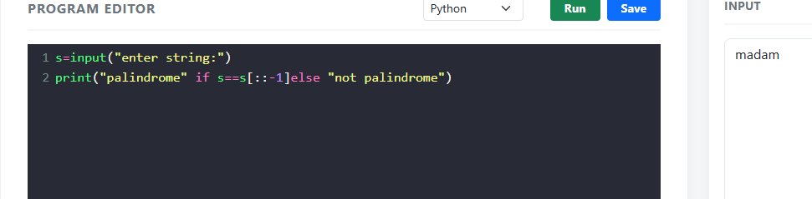
COUNT NUMBER OF WORDS USING SPLIT()
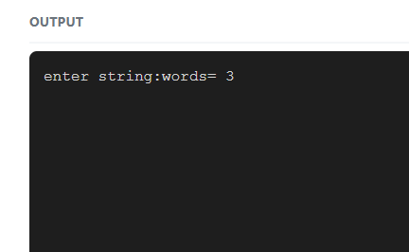
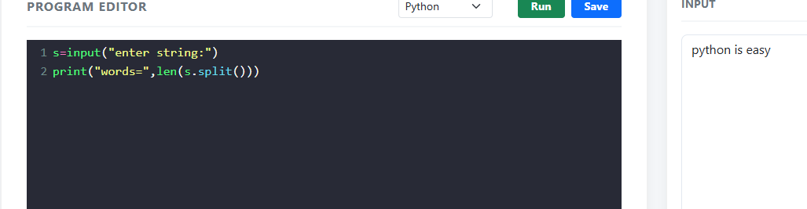
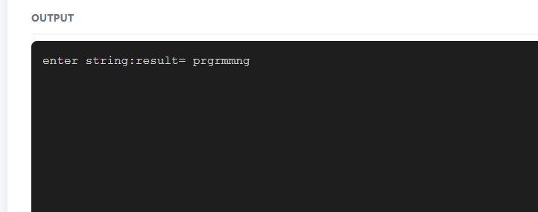
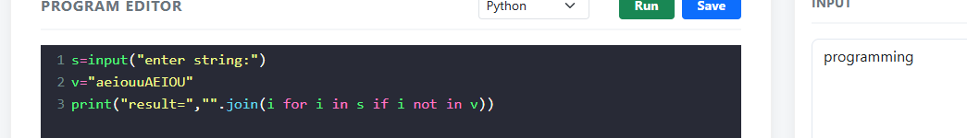
REMOVE ALL WORDS FROM A STRING

